April 2024 News Update

Healthwatch County Durham are Dementia Friends
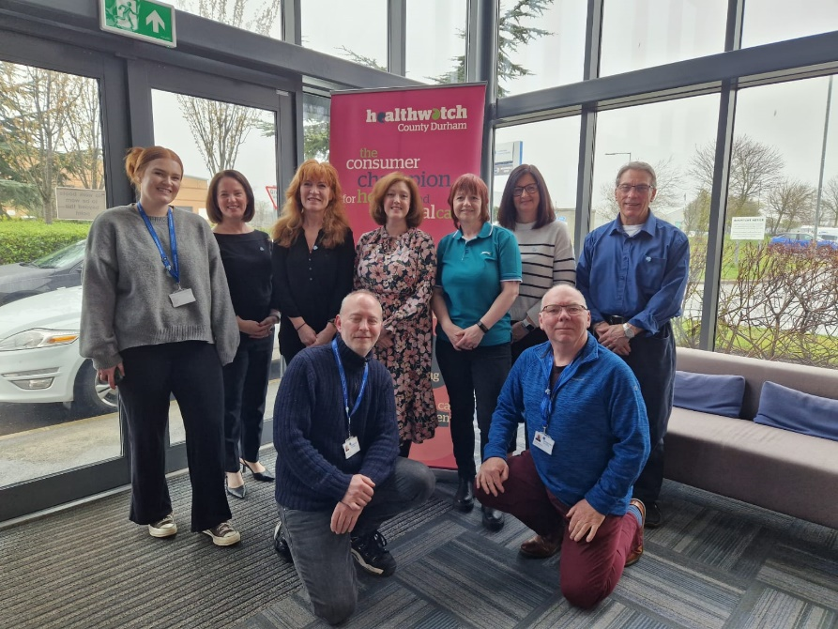
This month we carried out Dementia Friends training with the Alzheimer's Society and now Healthwatch County Durham are Dementia Friends. This means we understand more about what it's like to live with dementia and know how to help people who need help and support.
For more information on Dementia and becoming a Dementia Friend visit: dementiafriends.org.uk

Annual Event
We will be hosting our Annual Event on 3rd July at Bishop Auckland Football Club. There will be a buffet lunch, guest speakers and an online booking form will be going out soon for you to book on. Save the date!

We are recruiting board members
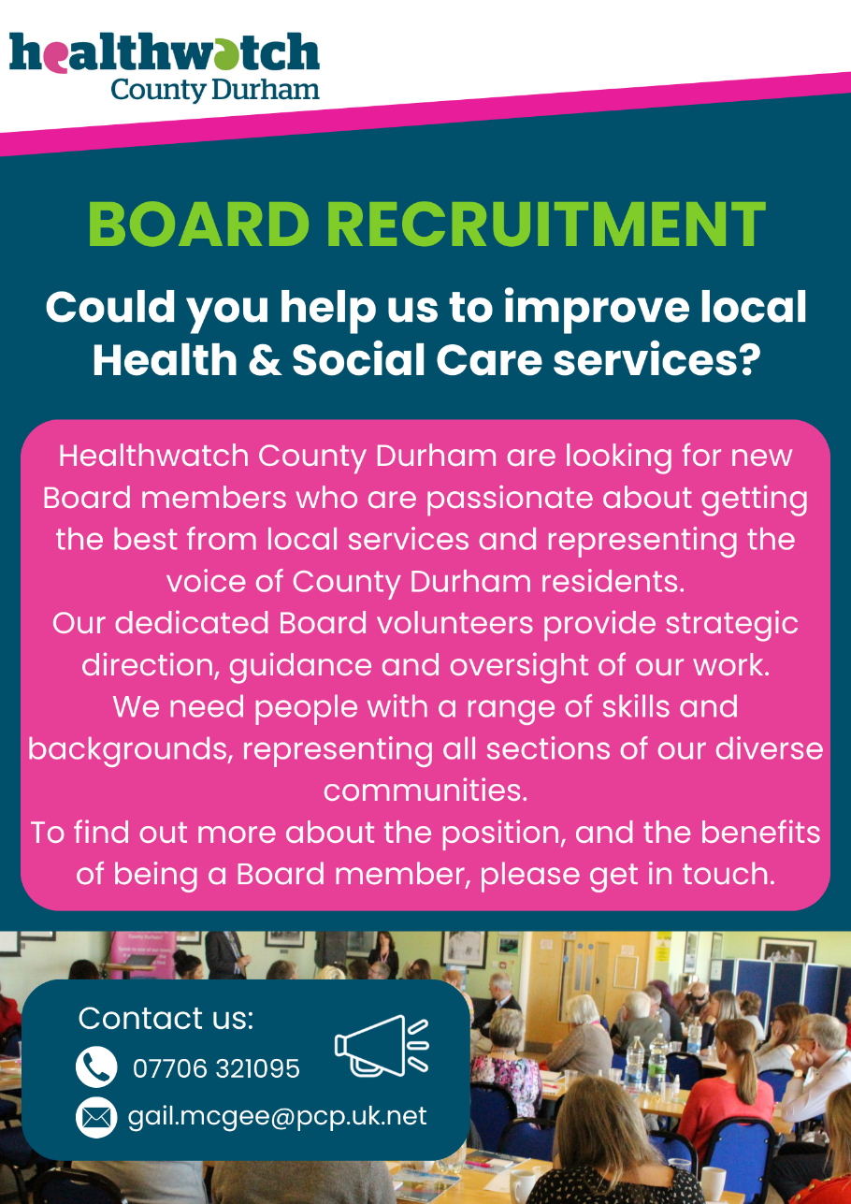

If you are interested in joining our board and think you have the relevant skills, please get in touch with our Project Lead Gail for a recruitment pack. Email gail.mcgee@pcp.uk.net or phone 07706 321095.

Dentistry Survey is now closed - thank you
Thank you to everyone who got involved and filled out our dentistry survey, we have received nearly 1000 responses from County Durham which is a great number. We will announce it once it has been drawn.
We will also share the report once it has been produced.

Supporting a young person with Autism course
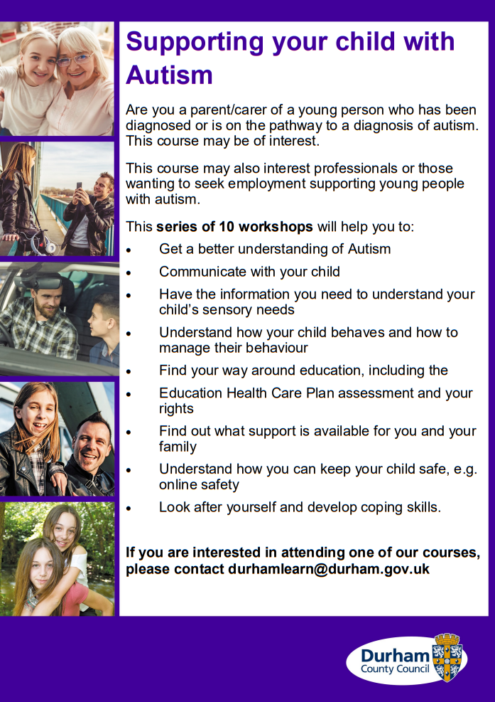

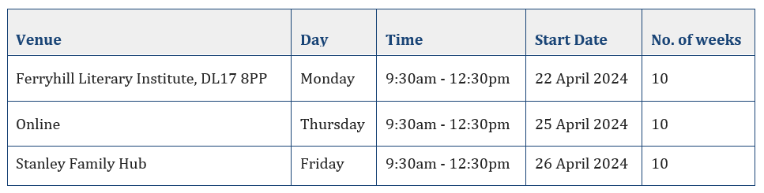

If you are a parent or carer of a young person with Autism or you work with young people with Autism this course could be of interest to you. There are days and it runs for 10 weeks. (See the dates above). If you would like more information or would like to book onto the course please email durhamlearn@durham.gov.uk

The Benefits of Nose Breathing
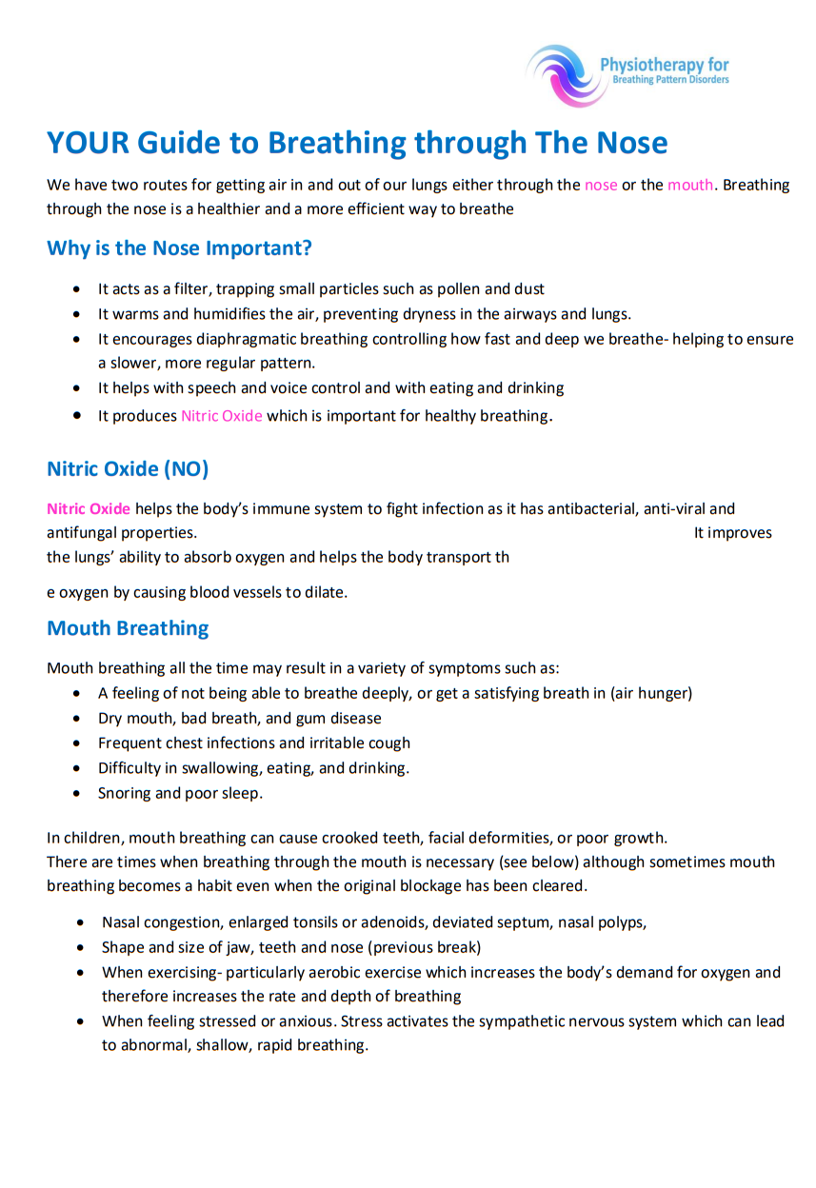

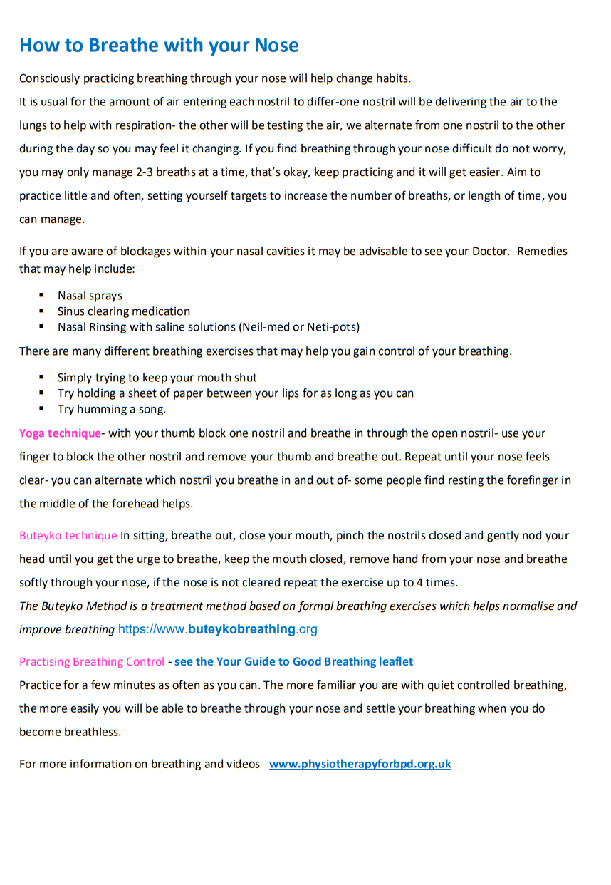
For more information on breathing visit: https://www.physiotherapyforbpd.org.uk/

Become a Community Champion
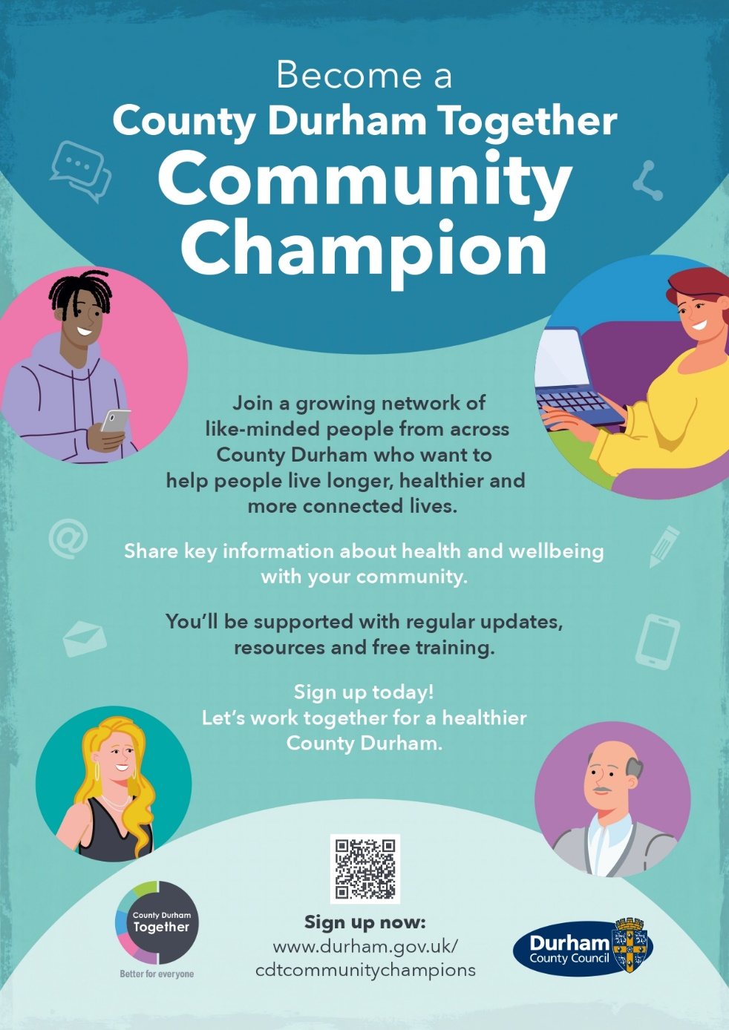
Could you be a County Durham Together Community Champion?
Do you see and talk to people in your community on a regular basis? Maybe you’re part of a group, club or sports team, or perhaps you just enjoy meeting people and having a chat.
If this sounds like you, and you have an interest in health and wellbeing, then you could become a Community Champion.

Durham and Dales Mental Health Transformation Launch
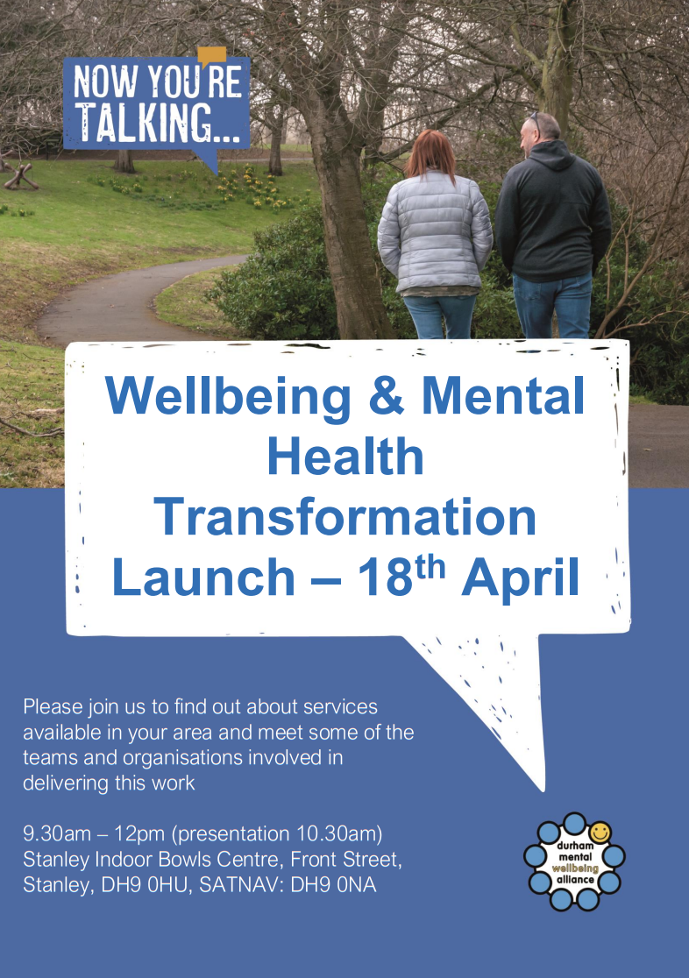
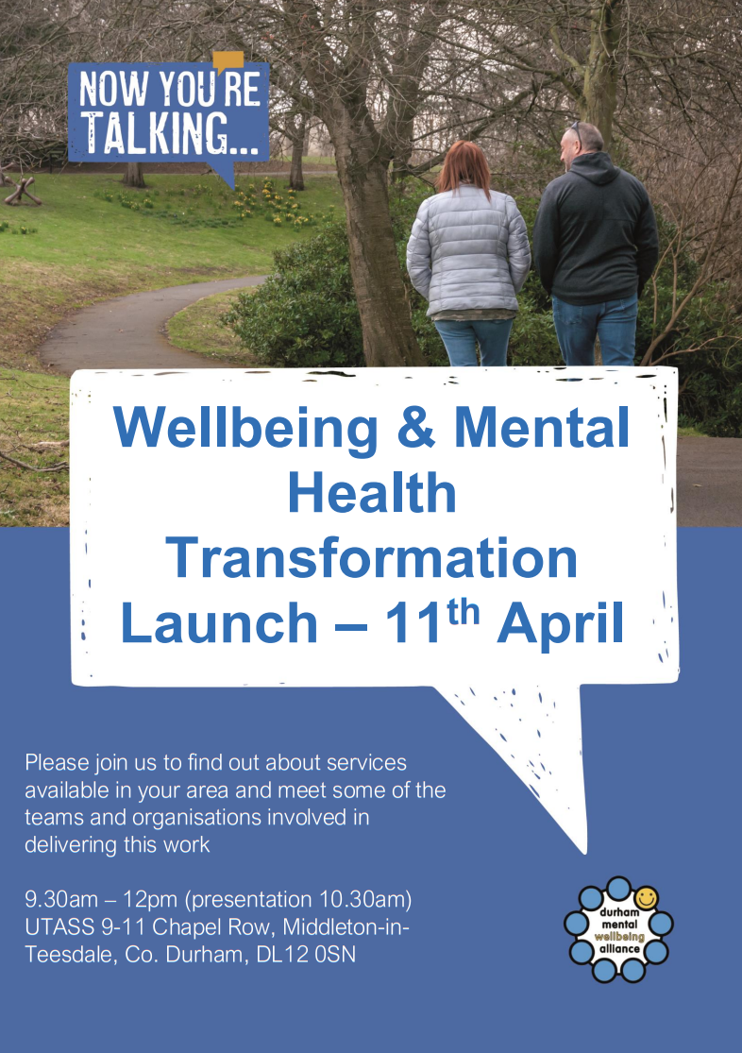

There are 2 Mental Health Transformation Launch events coming up in the area which will have service providers on hand to talk about the support they offer along with a short presentation about the changes being made to accessing services and making it easier.
They will be on the 11th April 9:30-12pm at UTASS or 18th April 9:30-12pm at Stanley Indoor Bowls Centre.
No booking required.

Parent Carer Forum for parents with children and young people with special educational needs
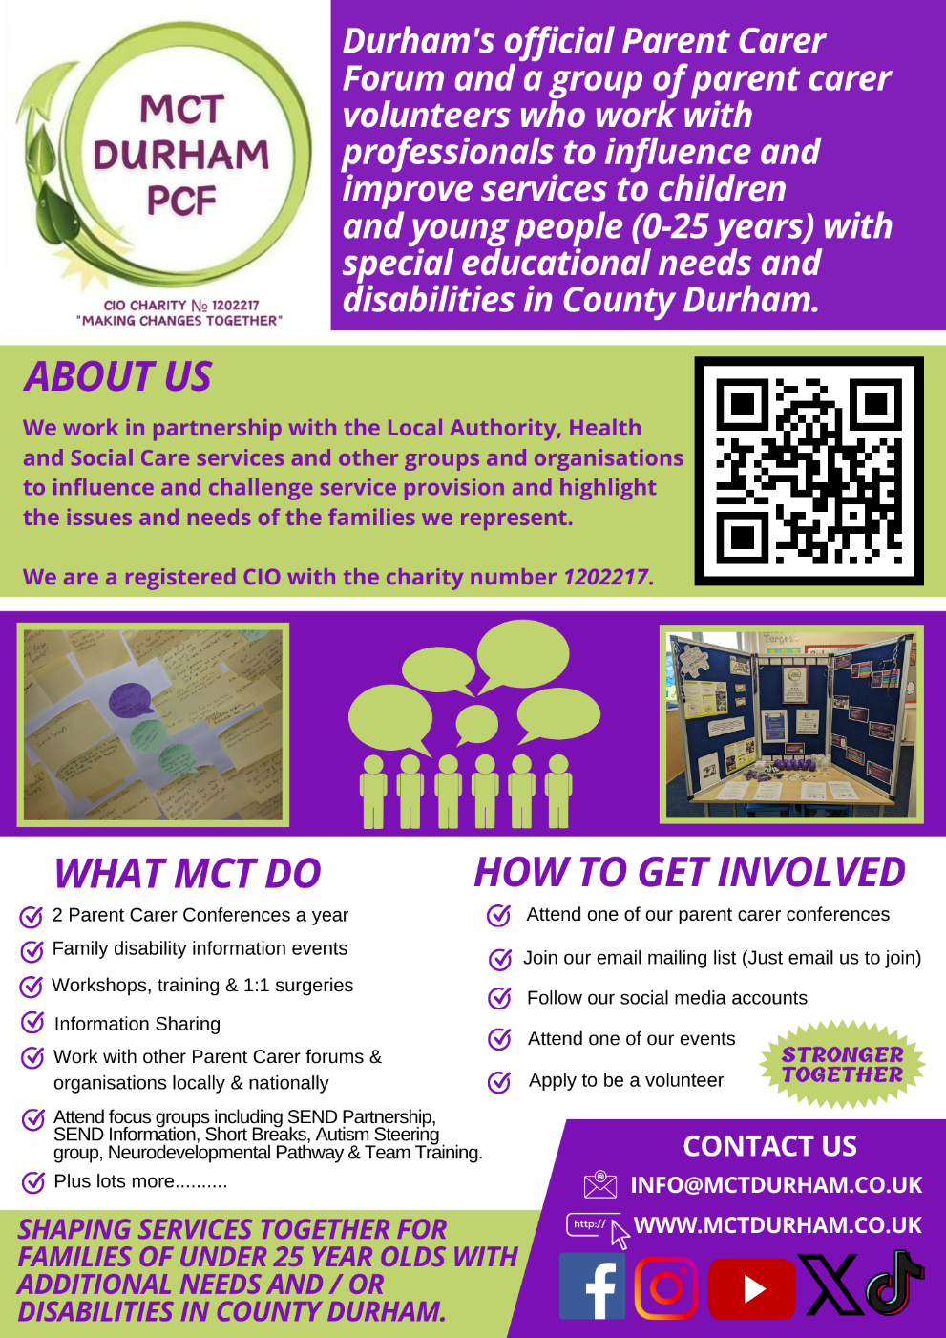

For more information visit the Making Changes Together website: www.mctdurham.co.uk

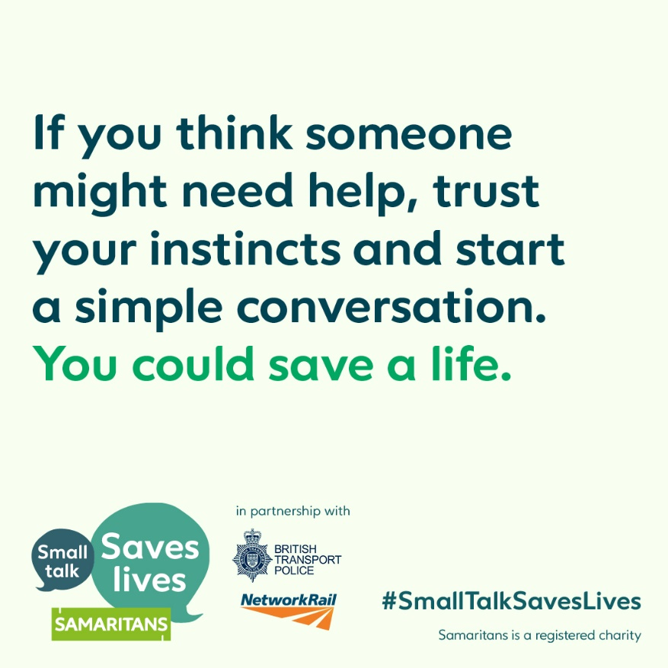
Small Talk Saves Lives - Samaritans

A little small talk and a simple question like “Hi, where can I get a coffee?” can be all it takes to interrupt someone's suicidal thoughts and could help set them on the journey to recovery.
Since launching in 2017, Small Talk Saves Lives has successfully raised awareness within railway stations and other public settings about the need to trust your instincts and start a simple conversation if you think someone might need help.
But there is more that can be done as only 50% of UK adults said they would feel confident approaching and speaking to someone they don’t know if they were concerned about them in public.
It’s normal to feel anxious about starting a conversation with a stranger. You might worry about saying the wrong thing – but having the confidence to act could help save a life.
Delivered in partnership with Network Rail, British Transport Police and the wider rail industry, the latest phase of Small Talk Saves Lives will run from 22 February to 19 March 2024.
Join thousands of people looking out for one another www.samaritans.org/smalltalksaveslives

Share your News

If you have anything you would like to share with us to put in the e-Bulletin, please get in touch and we will be able to include it in the future. This can include upcoming events, important information on health and social care and support around County Durham.
Email victoria.dixon@pcp.uk.net if you would like your information on the e-Bulletin.

Contact us:
Healthwatch County Durham
Whitfield House
St Johns Road
Meadowfield Industrial Estate
Durham
DH7 8XL
Freephone: 0800 3047039
Text: 07756 654218
Email: healthwatchcountydurham@pcp.uk.net

